NIT AWS/ ATF FEE SCHEDULE
(Prices are subject to change at facility manager’s discretion)

BOOTH RENTAL
This is for any individual interested in weld practice time. Test is not included, instructor is not included. To schedule, there is a 3 hour minimum.
- $75/hour (paid to NIT)
MAINTENANCE OF WELDER CERTIFICATION
This is to be used before the welder’s certification card is expired – if it has already expired, they must complete another weld test.
- Maintenance Fee: $25 (paid to NIT)
- AWS Certified Welder Maintenance Form: $25 (paid to AWS)
- AWS has a 60 grace period with a $50 additional charge
___________________________________________________________________________
SMAW, and FCAW Groove Tests, limited thickness (.375” Thickness)
(2 hour time limit for single position, 3.5 hour time limit for all position tests.)
- Single Position: $600
- 3G & 4G-all positions: $750
- Application Fee: $50 (paid to AWS)

SMAW and FCAW Groove Tests, unlimited thickness (1.00”Thickness)
(4-hour time limit, 6-hour time limit for all position tests.)
- Single Position: $600
- 3G & 4G-all positions: $800
- Application Fee: $50 (paid to AWS)

SMAW, FCAW, GTAW FILLET WELD (0.500”)

- Single Position: $300
- 3G & 4G-all positions: $350
- Application Fee: $50 (paid to AWS)

SMAW, GTAW, FCAW STEEL Pipe Test, (6” or 8” Schedule 40 or 80)
(6-hour time limit)
- 6G: $950
- Application Fee: $50 (paid to AWS)

AWS Testing for current or previous NIT welding students:
- $130 per/test (paid to NIT)
- $50 application fee (AWS collects the application fee)
__________________________________________________________________________________
RETESTING
If a candidate fails a welding test, they have the option of scheduling a re-test at a 25% discounted rate of the test.
(Some code books require additional training or practice before retesting)

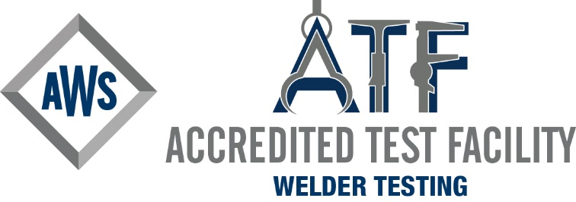

AWS / ATF Contact Information
Jason Lenoir
ATF Welding Facility Manager
Jason.lenoir@nitalaska.com

NOTE: If interested in tests not listed above, please inquire with Test Facility Manager.

